SLIDE 1
Understanding Who Has Power, How We Shift Them,
And How We Build Our Own Power
0:00–0:10
SLIDE 2
Acknowledgement of Country (focus on power)
SLIDE 3
- “When you think about power in society — who comes to mind?”

I want to start with a really broad question tonight, and there’s no right or wrong answer to it.
When you think about power in society — who comes to mind?
You can pop thoughts in the chat, or unmute if you’d like.
Hopefully conversation will happen naturally.
If they immediately think of politicians, governments, billionaires, CEOs, police, the media — remind them those are definitely important parts of the picture.
But one of the things I want us to think about tonight is that power is usually much bigger and more complicated than just “the people at the top.”
Power can sit in institutions, laws, money and media narratives.
It can sit with who gets listened to, and who gets ignored.
It can sit in systems that shape people’s lives every single day, Housing systems, welfare systems, policing systems, economic systems.
And at the same time, power can also come from organised people.
From communities like ours. From our relationships. From our collective action.
So tonight’s really about trying to unpack:
Who has power?
How do they maintain it?
What actually shifts them?
And how do ordinary people build power together?

0:10–0:20
SLIDE 4
“How Campaigns Win”
One thing we often learn pretty quickly in campaigning is that people in power usually don’t just wake up one day and decide to do the right thing… change usually happens because pressure builds
Governments, corporations, institutions respond when the cost of ignoring people starts becoming too high.
That pressure can look different:
- public pressure
- political risk
- media scrutiny
- organised communities
- changing public attitudes
And most successful campaigns use several of these things at once.
A useful way to think about this is through four things:
Public Pressure: Getting attention, visibility, mobilisation, public support.
Political Risk: Making inaction uncomfortable, either electorally, reputationally or socially.
Narrative Shift: Changing how people understand an issue.
For example: moving from “people are poor because they failed” to “people are poor because systems are failing them.”
Organised People: Relationships to build trust, consistency and collective action. Movements are built by organised people, not just good ideas.
You can have the best argument in the world, but if nobody is organised around it, governments often ignore it.
So I want us to think a bit now about what actually creates pressure…

0:20–0:35
SLIDE 5
Group Discussion: “Have you seen public opinion shift on an issue in your lifetime?”
Discussion

SLIDE 6
Now we’re going to talk about….
“What actually creates pressure?”
SLIDE 7
Governments usually respond when there’s some kind of cost to ignoring people.
That cost might be:
- losing votes
- bad media coverage
- public embarrassment
- internal pressure from within their own party
- sustained community anger
- pressure from organised groups
- disruption to “business as usual”
Different governments respond to different kinds of pressure — but very few governments change because people politely asked once.
So a useful question for campaigners is:
“What pressure exists here, and what pressure are we capable of building?”
SLIDE 8
“Why do some protests or campaigns get ignored?”
Sometimes campaigns get ignored because they’re too small or short-term.
Sometimes it’s because they don’t clearly target the people with actual decision-making power.
Sometimes there’s lots of moral passion, but not enough strategy.
And sometimes governments actually think:
“Yes, people are angry — but they’ll move on in a week.”
A lot of successful movements weren’t successful because they were instantly massive — they were successful because they were persistent, strategic, organised, and able to shift public attitudes over time.

SLIDE 9
“What makes politicians nervous?”
Usually:
- losing votes
- losing legitimacy
- becoming publicly associated with a harmful system or policy
- sustained bad publicity
- organised communities
- visible public anger
- divisions inside their own party
- growing movements they can no longer ignore
Politicians often tolerate criticism.
What worries them more is organised criticism that keeps growing.
Especially when:
- media starts paying attention
- public opinion shifts
- more people get involved
- respected organisations join in
- people stop accepting the status quo
SLIDE 10
“Can relatively small groups still have influence?”
Absolutely.
Small groups can sometimes have enormous influence if they:
- are strategic
- are disciplined
- are organised
- understand where power sits
- build strong relationships
- tap into broader public feeling
- shift narratives
SLIDE 11
A lot of major social change started with relatively small groups of people who were initially dismissed.
Movements often look “sudden” at the end — but usually there were years of smaller organising efforts beforehand.
Sometimes really small groups can have influence if they’re strategic, organised, persistent, or able to shift public narratives.”
One of the reasons some campaigns are more effective than others is because they understand where power actually sits…and that’s the important part.

0:35–0:47
SLIDE 12

Power Mapping Activity
Choose ONE issue:
Example:
“More Public Housing in SA”
Discussion:
- Who actually has decision-making power?
- Who influences them?
- What pressure points exist?
- Who are allies?
- What tactics might work?

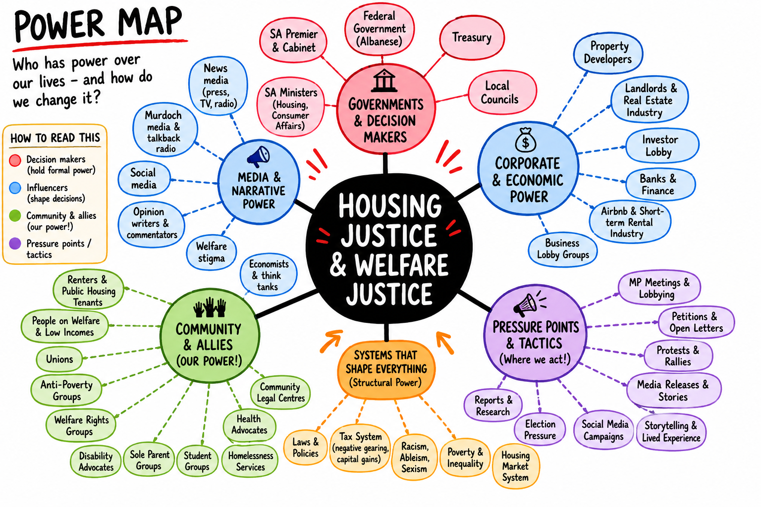

We need to reframe our thought from being people who perceive ourselves as powerless individuals to potential collective actors/volunteers etc.
0:57–1:00
Final Reflection
Not sure what to ask them, something like “What’s one idea you’re leaving with tonight?” or “What’s one thing this session made you think about differently?” Any suggestions?
Do we know what our next online session is and the date, we can announce it?

